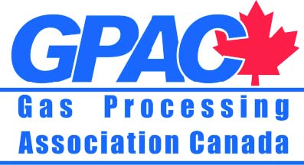
AWARD OF
OUTSTANDING ACHIEVEMENT

NOMINATION FORM
Submission Deadline: March 31, 2015
The award of Outstanding Achievement is awarded annually to a worthy recipient
in recognition of innovation and/or performance within the gas processing and gas liquids industry.
Name of Nominee:
Company:
Address:
Phone: Email:

All members, companies/individuals in good standing of GPAC are eligible.

We feel this company / individual most reflects leadership in the following areas:
*Circle one or more
Vision Best Practices Innovation Social Impact
Leadership Excellence Technology Attitude
Why you feel this company / individual should be considered:

Name of Nominator:
Company:
Address:
Phone: Email:
Return completed form by March 31, 2015 to:
Fax: 403-244-2340 or Email: info@gpacanada.com
*Presentation will take place at the GPAC Annual General Meeting.

