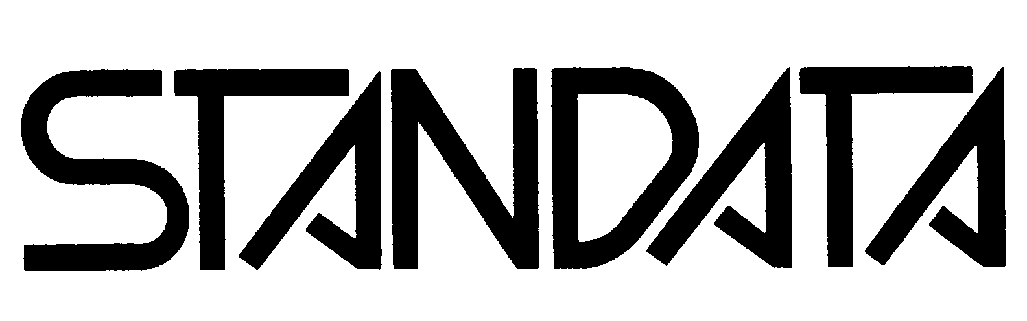
GAS SAFETY

Information Bulletin

January 2015 G-03-11-ABSA
Page of 6

SUBJECT: Fuel Gas Pressure Piping in Plants

TO: All Accredited Inspection Authorities, Safety Codes Council, Gas Utilities, Federation of Alberta Gas Co-ops, Canadian Propane Association (CPA) Members, Propane Suppliers, Commercial and Industrial facilities as well as Gasfitters/installers.

This bulletin has been jointly developed by Safety Services, the Boilers & Pressure Vessels Sub Council, the Alberta Boilers Safety Association (ABSA) and the Gas Sub Council to inform industry of the requirements associated with the installation of fuel gas pressure piping in Alberta.

The purpose of this Information Bulletin is to ensure that Designers and Installers are aware of the provisions for fuel gas service pressure piping above and below 15 psi (103 kPa) and of the overlap with the authorities having jurisdiction before work proceeds.

This STANDATA establishes 15 psi (103 kPa) pressure as the specification break point between the Gas Code Regulation and the Pressure Equipment Safety Regulation for piping in fuel gas service installed at Owner-user facilities:

- Fuel gas piping for pressure not exceeding 15 psi (103 kPa) shall be designed and constructed in accordance with the Gas Code Regulation

- Fuel gas piping for pressure exceeding 15 psi (103 kPa) shall be designed and constructed as “pressure piping” in accordance with the Pressure Equipment Safety Regulation.

All fuel gas piping systems shall be permitted and meet the requirements of the Gas Code Regulation, except if the installation is at an Owner-user facility.

The CSA B149.1 Natural Gas and Propane Installation Code addresses all pressure values and all locations for piping that conveys fuel gas to fuel burning appliances.

The Pressure Equipment Safety Regulation under the Safety Codes Act adopts certain ASME B31 Piping Codes and the CSA B51 Boiler, pressure vessel, and pressure piping code. The Pressure Equipment Safety Regulation addresses “pressure piping” (as defined below). However, fuel gas piping used for fuel purposes regulated under the Gas Code Regulation is specifically exempt from the Pressure Equipment Safety Regulation.

The Pressure Equipment Safety Regulation does not apply to:
- a pressure piping system operating at and with relief valves set at 103 kPa (15 psig) or less;
- piping systems used to convey gas exclusively for fuel purposes and that is subject to the Gas Code Regulation (AR 111/2010);

Administration of the Pressure Equipment Safety Regulation has been delegated to ABSA.
In the Pressure Equipment Safety Regulation, the following definitions apply to the design and construction of a pressure piping system:

"Pressure Piping System" means pipe, tubes, conduits, fittings, gaskets, bolting and other components that make up a system for the conveyance of an expansible fluid under pressure and may also control the flow of that fluid.

"Expansible Fluid" means
(i) a vapour or gaseous fluid, or
(ii) a liquid under pressure and at a temperature at which the liquid changes to a gas or vapour when the pressure is reduced to atmospheric pressure or when the temperature is increased to ambient temperature.

In this document the term
“Owner-user” means an owner of pressure equipment that has provided an Integrity Management System in accordance with the Pressure Equipment Safety Regulation and has been issued a quality management system Certificate of Authorization Permit under PESR section 11(3).

“Fuel Gas” means any of the following gases or mixtures of them: natural gas, manufactured gas, or mixtures of propane gas and air, propane, propylene, butanes (normal butane or isobutane), and butylene. And includes manufactured gas such as hydrogen, raw gas, well head gas, process generated gas and may include sweet, sour or wet applications.

The Gas Code Regulation AR 111/2010 adopted the CSA-B149.1-2010, Natural Gas and Propane Installation Code. This code applies to the installation of piping and tubing systems, appliances, equipment, components, venting and accessories where gas is to be used for fuel purposes, but does not cover piping or tubing where the gas is used as feedstock or process gas.

Installations using manufactured gas (as defined above) shall meet the intent of the Gas Code Regulation by utilizing appliances that are certified or approved as indicated under the options within the Gas Code Regulation and through the Province-wide variance. Hydrogen gas as a fuel is currently addressed as an extension of a B149.1 permitted installation that would address the installation of the piping and be considered as compliant under complex projects requiring the engineer of record to reference the CAN/BNQ 1784-000 Canadian hydrogen code.

Permitting requirements under both Gas & Boiler Disciplines

The Safety Codes Act, under the Permit Regulation, Alberta Regulation 204/2007, indicates that a permit, for a gas installation that is under the gas discipline, is required:

“12(1) A permit in the gas discipline is required to install, alter or add to a gas system.”

Work performed on piping under the jurisdiction of the Gas Code Regulation must be done by certified gas fitters.

Work performed under the jurisdiction of the Pressure Equipment Safety Regulation shall follow the requirements outlined therein and in accordance with ABSA document AB-518.

Fuel gas piping systems at owner-user plant sites.

- Fuel gas piping systems installed at owner-user facilities having a design pressure in excess of 15 psi(103 kPa) shall be deemed pressure piping and subject to the Pressure Equipment Safety Regulation and shall be included in the design registration of the pressure piping system for the facility.

- The construction, modification, repair or alteration of a fuel piping system referenced in point 1 above shall be performed by the holder of a quality management system certificate of authorization permit and in full compliance with the Pressure Equipment Safety Regulation.

- The construction inspection of the piping upstream of the appliance isolation valve and/or the pressure regulator shall be carried out by an owner’s inspector in accordance with the code of construction and documented on an ABSA form AB-83 Piping Construction and Test Data Report.

- The installation inspection of the piping system appliance isolation valve and/or pressure regulator will be carried out by a gas safety codes officer under the Gas Code Regulation. The required gas permit will cover the installation of the gas-fired appliance and the final piping where gas is used for fuel purposes.

Installation inspection carried out under Gas Safety Regulation shall include:
- Verification from the owner or contractor that the pressure piping system has been registered with ABSA;
- Verification the AB-83 form has been completed and signed off by the owner’s inspector.
- Installer qualifications (gasfitter) respecting the type of installation permitted;
- Piping and tubing systems (size, schedule, capacity, supports, etc.);
- Pressure regulators and line relief devices (working pressures, capacities, venting to a safe location outdoors);
- Appliances (certification, approvals for Alberta, clearances, protection, venting systems and air supply);
- For underground piping and tubing (burial depth, not permitted under building, sleeves on riser passing through concrete/pavement, swing joint on entry to buildings, etc.)
- Odorization or equivalent (when process gas is utilized for fuel purposes); and
- Other inspection items associated with B149 Codes and referenced standards.

Fuel gas piping systems at all other plant sites not managed by an Owner-user.

- Fuel gas piping systems installed at all design pressures shall be deemed fuel gas piping and subject to the Gas Code Regulation.

- The construction, modification, repair or alteration of a fuel piping system reference in point 1 above shall be performed by a holder of an appropriate trade certificate of competency and in full compliance with the trade regulations under Alberta Innovation and Advanced Education / Apprenticeship and Industry Training (AIT).

- The installation inspection of the piping system including appliances, isolation valve and/or pressure regulator will be carried out by a gas safety codes officer under the Gas Code Regulation. The required gas permit will cover the installation of the gas-fired appliance and the final piping where gas is used for fuel purposes.

Installation inspection carried out under Gas Safety Regulation shall include:
- Verification from the owner or contractor that the pressure piping system (if applicable) has been registered with ABSA;
- Installer qualifications (gasfitter) respecting the type of installation permitted;
- Piping and tubing systems (size, schedule, capacity, supports, etc.);
- Pressure regulators and line relief devices (working pressures, capacities, venting to a safe location outdoors);
- Appliances (certification, approvals for Alberta, clearances, protection, venting systems and air supply);
- For underground piping and tubing (burial depth, not permitted under building, sleeves on riser passing through concrete/pavement, swing joint on entry to buildings, etc.)
- Odorization or equivalent (when process gas is utilized for fuel purposes); and
- Other inspection items associated with B149 Codes and referenced standards

A natural gas service and meter upstream of a gas distribution system on a plant site shall be in accordance with the Pipeline Act, regulations under that Act including referenced codes/standards.

Anyone concerned about the status of a fuel gas piping system or a pressure piping system could contact Alberta Municipal Affairs, Safety Services office, visit the Web site, www.municipalaffairs.alberta.ca/cp_index.cfm, contact the local ABSA office or visit ABSA Web site, http://www.absa.ca/ for further information

Mike Poehlmann Sidney Manning
Administrator and Chief Inspector Chief Administrator/Inspector
Pressure Equipment Safety (ABSA) Plumbing and Gas (AMA)

Gas Supplier Distribution line (Alberta Resource Development, Rural Utilities Branch)

Process Distribution ABSA – Registered Pressure piping system

Fuel Distribution Gas Safety / ABSA Registered for Owner-User if pressure >15psi
Appliance
(Certified / Uncertified) Gas Safety

Plant Site

Gas Supplier Regulator
and Gas Meter Station ⇒

Process Building

Security Gate

Administration Building

Process Heater

Maintenance Building

PPPP

Process Building
B
Mechanical Room

MUAH – Roof top Make-up Air Units B – Boiler (Space Heating) UH – Unit Heater HWT – Hot Water Tank

Process Heater
MUAH
HWT
UH

Process Equipment

Process Heater

Fuel Train
Burner

Process Equipment Owner-User Over 15 PSI

Process Heater

Fuel Train
Burner

